ECA6102 – COMPUTER NETWORKS AND CYBERSECURITY

NAME: RAGAVARSHINI R
REG.NO: 192512027
EXP – 01
Build a LAN topology in Cisco Packet Tracer
- Implementation of Star topology
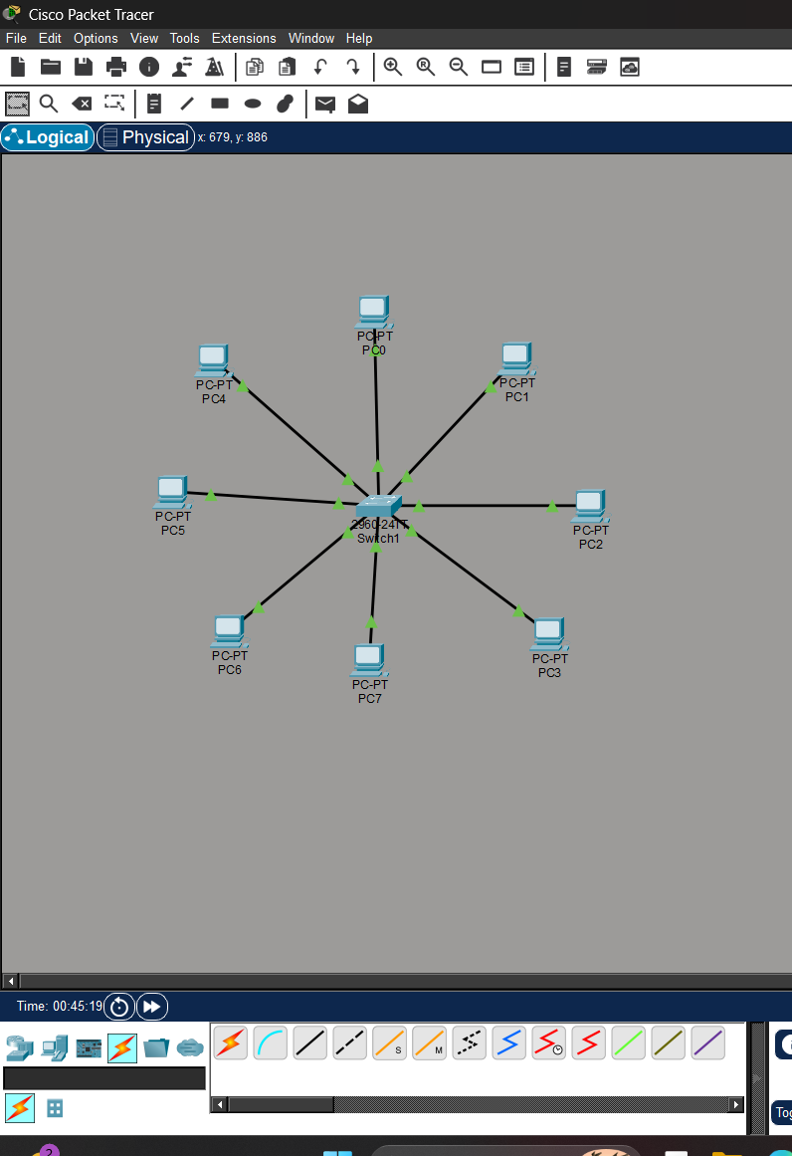

- Implementation of Mesh topology
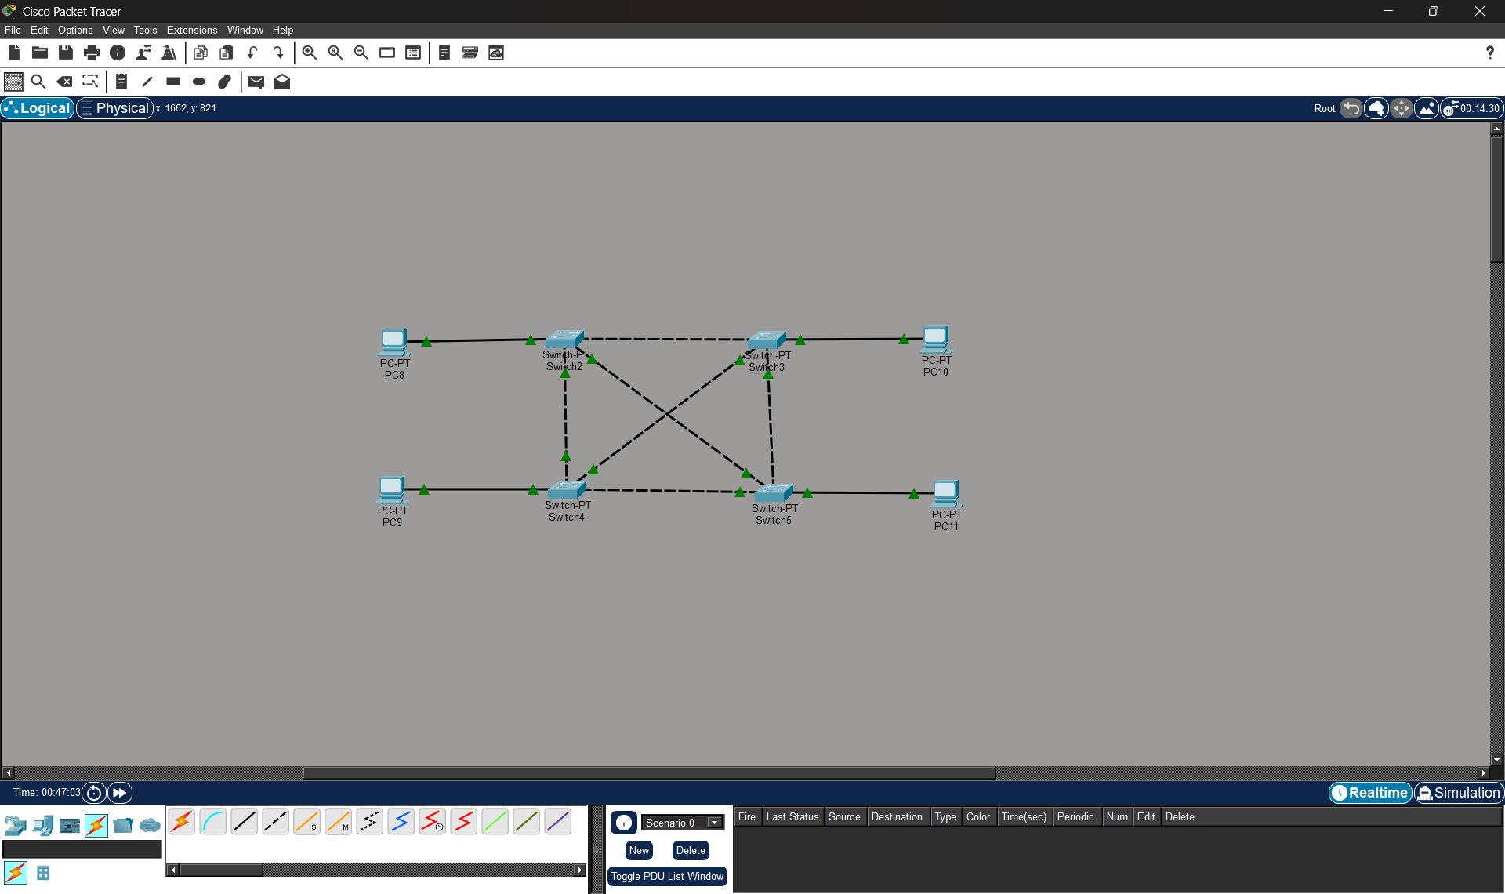
3) Implementation of Hybrid Topology
